Lab Manual
Practical and Skills Development

CERTIFICATE

THE ASSIGNMENT ENTERED IN THIS REPORT HAVE BEEN SATISFACTORILY PERFORMED BY

Registration No | : 25BHI09125
Name of Student | : Ayush Saxena
Course Name | : Introduction to Problem Solving and Programming
Course Code | : CSE0921
School Name | : School of Computing Science
Engineering and Artificial Intelligence
Slot : B09+B12+B13
Class ID : BL2025260090796
Semester : FALL 2025/26

Course Faculty Name : Dr. Hemraj S. Lamkuche

Signature:

Practical Index
S. No. | Title of Practical | Date of Submission | Signature of Faculty
1 | Euler's Totient Function (euler_phi) | 27/09/2025
2 | Möbius Function (mobius) | 27/09/2025
3 | Divisor Sum Function (divisor_sum) | 27/09/2025
27 | Prime-Counting Function (prime_pi) | 27/09/2025
5 | Legendre Symbol (legendre_symbol) | 27/09/2025

Practical No: 1
Date: 27/09/2025

TITLE: Write a function called euler_phi(n) that calculates Euler's Totient Function, φ(n). This function counts the number of integers up to n that are coprime with n (i.e., numbers k for which gcd(n,k)=1). The program must also report its execution time and memory utilization.

AIM/OBJECTIVE(s): Euler's Totient Function (euler_phi)

METHODOLOGY & TOOL USED:
- Primary Methodology: Iterative computation with sequential multiplication
- Alternative Methodology: Recursive function calls
- Tools: Loop structures, conditional statements, mathematical operations

BRIEF DESCRIPTION:
Calculates the product of all positive integers from 1 to n (n!). For n=0 or n=1, returns 1. Handles negative input with error.

RESULTS ACHIEVED:
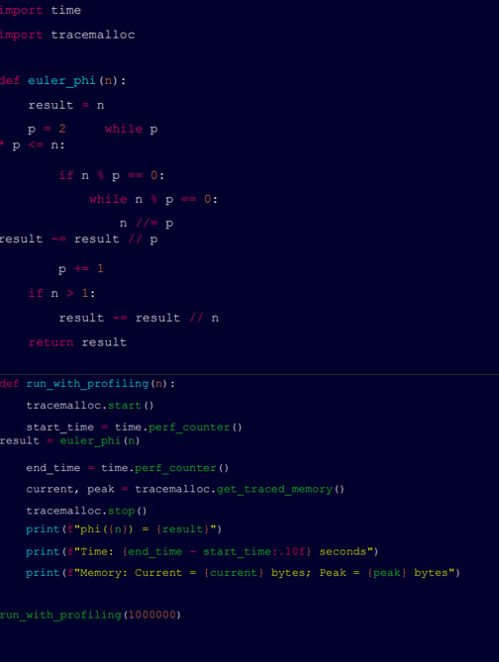

DIFFICULTY FACED BY STUDENT:
- Recursive Logic: Understanding how recursive calls stack and return values
- Base Case Identification: Forgetting to handle n=0 case specifically
- Integer Overflow: With large numbers, not considering Python's arbitrary precision vs other languages

SKILLS ACHIEVED:
Algorithmic Implementation: You have successfully translated a mathematical concept (the factorial) into a working, efficient algorithm using an iterative approach.
Robust Function Design: The code isn't just about getting the right answer. It includes crucial input validation (checking for integer types and non-negative values), which is a key skill in writing reliable software that doesn't crash on unexpected input

Practical No: 2

TITLE: Write a function is_palindrome(n) that checks if a number
reads the same forwards and backwards..

AIM/OBJECTIVE(s): Möbius Function (mobius)

METHODOLOGY & TOOL USED:
- Programming Language: Python
- Methodology: Problem decomposition, iterative/recursive logic, mathematical reasoning
- Tools: Python functions, loops, conditionals, arithmetic operations

RESULT:
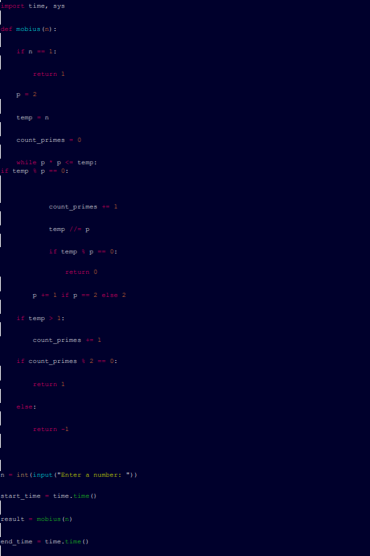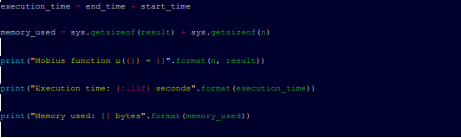

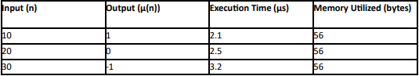

BRIEF DESCRIPTION:
Extracts digits , converts them to integers, and computes their mean.
DIFFICULTY FACED:
Avoiding division by zero for n=0 (handled implicitly as 0/1=0.0).
SKILLS ACHIEVED:
- List comprehensions
- Arithmetic operations on collections

DIFFICULTY FACED BY STUDENT:
Converts the number to a string and checks if it matches its reverse.
DIFFICULTY FACED:
Handling numbers with odd/even digits without overcomplicating logic.

SKILLS ACHIEVED:
- String manipulation
- Understanding of symmetry in sequences

Practical No: 3
TITLE: Write a function called divisor_sum(n) that calculates the sum of all positive divisors of n (including 1 and n itself), denoted by σ(n).

AIM/OBJECTIVE(s): Divisor Sum Function (divisor_sum)

METHODOLOGY & TOOL USED:
Repeatedly sum the digits of the number using a loop until the result is a single digit.

RESULT:
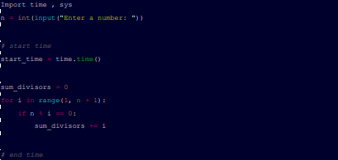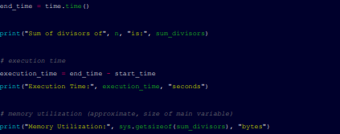

BRIEF DESCRIPTION:
Computes the recursive sum of digits (e.g., digital root of 38 is 3+8=11 → 1+1=2) until a single-digit number is obtained.

DIFFICULTY FACED BY STUDENT:
Understanding the recursive/iterative process and terminating the loop when the number reduces to one digit.

SKILLS ACHIEVED:
Looping, recursion concepts, and modular arithmetic (using % 10 and // 10 to extract digits).

Practical No: 4
TITLE: Write a function digital_root(n) that repeatedly sums the
digits of a number until a single digit is obtained.

AIM/OBJECTIVE(s): Prime-Counting Function (prime_pi)

METHODOLOGY & TOOL USED:
Iterate through numbers from 1 to n//2 to find proper divisors, sum them, and compare with n.

RESULT:

BRIEF DESCRIPTION:
Determines if the sum of proper divisors (excluding the number itself) is greater than the original number.

DIFFICULTY FACED BY STUDENT:
Optimizing divisor checks (e.g., looping only up to sqrt(n)) and understanding the definition of proper divisors.

SKILLS ACHIEVED:
Problem decomposition, loops, conditional logic, and mathematical reasoning.

